Design Lab Experiment No. 3:
Temperature Sensing System using Bluetooth

By: Alan Palayil
Lab Partner: Individual
Instructor: Prof. Jafar Saniie, Prof. Won-Jae Yi
TA: Mikhail Gromov
ECE 442 Internet of Things and Cyber Physical Systems
Date: 06-03-2022

Acknowledgment: I acknowledge all works including figures, codes and writings belong to me and/or persons who are referenced. I understand if any similarity in the code, comments, customized program behavior, report writings and/or figures are found, both the helper (original work) and the requestor (duplicated/modified work) will be called for academic disciplinary action.

Signature: ____Alan Biju Palayil__________

I. Introduction
A. Purpose
The purpose of this experiment is to get familiar with the temperature sensing system using DHT11 temperature sensor wired to the Arduino Uno board which transmits the data from the sensor to the Pi via HC-06 Bluetooth module and uploads the data to ThinkSpeak to visualize the data through the internet. This experiment shows how Arduino communicates via the Bluetooth with the Raspberry Pi and the process to upload data to the cloud.
B. Background
The Arduino Uno and Raspberry Pi are the key components of this lab. Using Arduino to program the board and sensors and python script for the Raspberry Pi. The DHT11 temperature sensor is connected to the Arduino where it can transmit the data over to the Pi using Bluetooth. The temperature sensor monitors the ambient temperature and humidity and measures the data in Centigrade. The HC-06 module can be configured using AT commands over serial connection. The HC-06 Bluetooth module acts as a slave device, the connection is made by pairing it with the Pi using RFCOMM. ThinkSpeak is an IoT open-sourced application and API to retrieve and store data from various sensors using HTTP over the internet via LAN.
II. Lab Procedure and Equipment List
- Equipment
  - 1 x Raspberry Pi 3 single-board computer
  - 1 x Arduino UNO board and USB cable
  - 1 x HC-06 Bluetooth transceiver
  - 1 x LM35 Ambient Temperature Sensor or DHT11 Temperature and Humidity Sensor
  - 1 x 5K or 10K Ohms Pull Up Resistor (for DHT11 Sensor)
  - 1 x Breadboard

- Procedure
*Refer to Lab Manual for detailed Procedure*
III. Results and Analysis
- Results
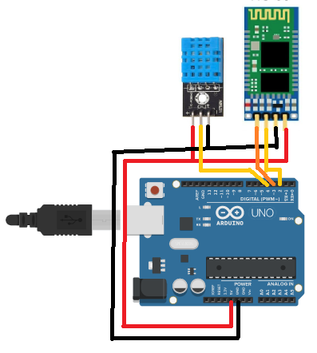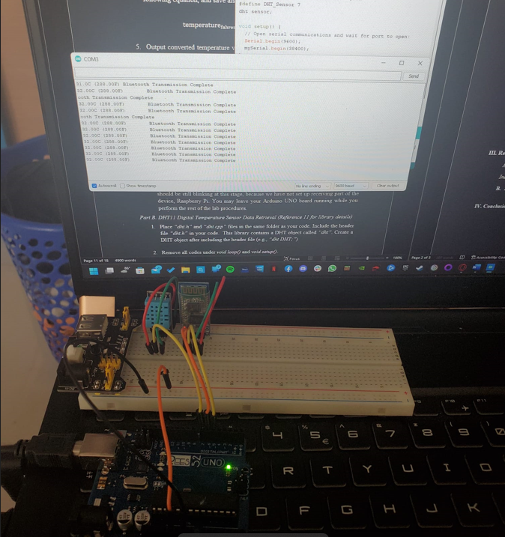
Schematics for the DHT11 sensor and HC-06 module with the Arduino
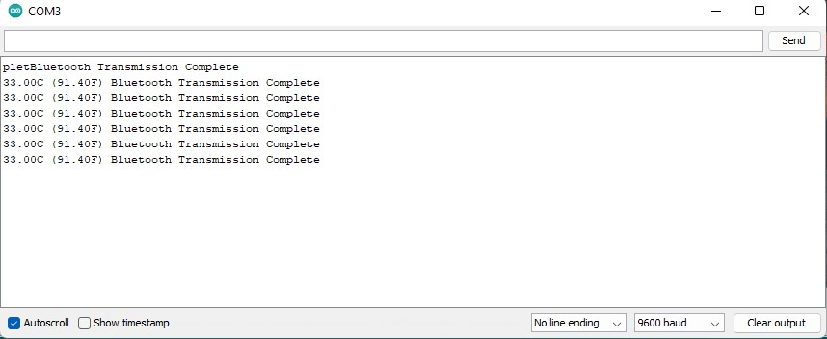
COM3 on Arduino
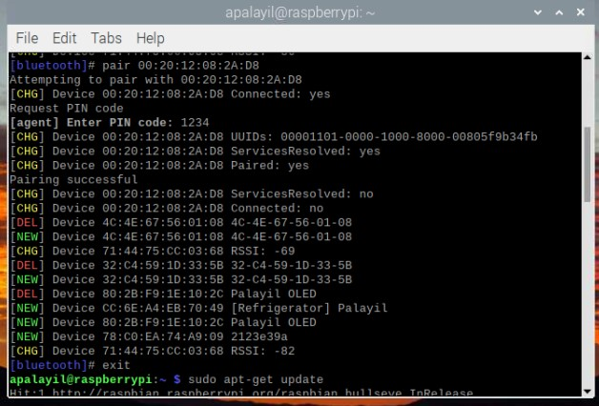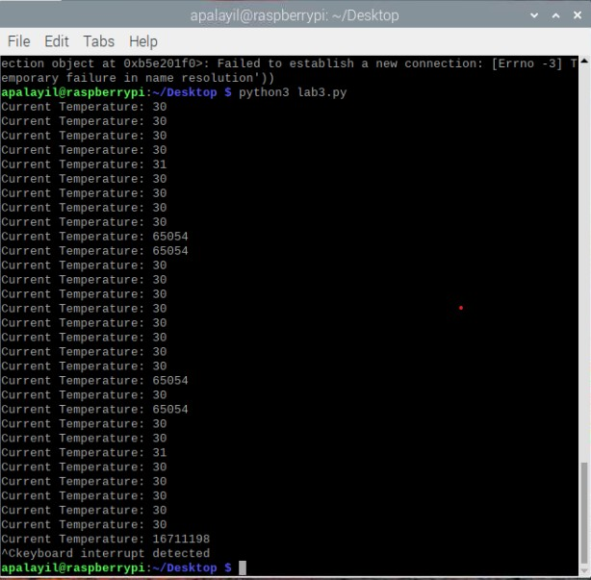
Pairing and Python script on Raspberry PI
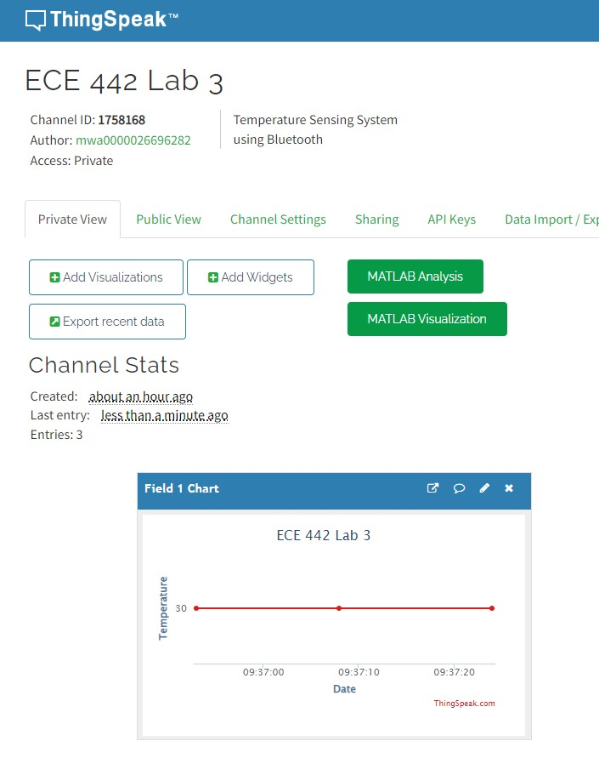
ThinkSpeak channel for Temperature Graph
- Answers to Discussion Questions
  - See Appendix for the fully commented code.

  - Flowchart of the overall Temperature Sensing System
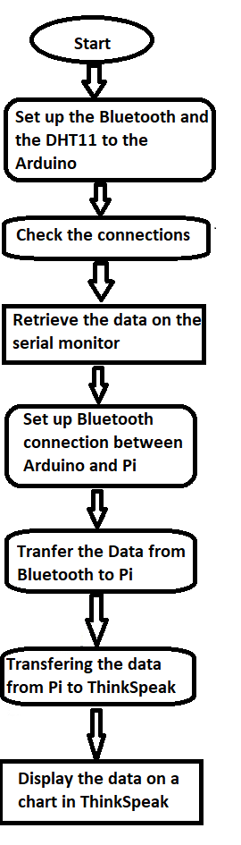

  - The datasheet of Atmega states that its ADC has a definition of 10-bits (1024 values), so a formula is used to convert the retrieved integer from Analog to Digital. The temperature is calculated in Celsius using the given formula:
temperature_celsius= ((((raw_sensor_value)/1024)*5000)/10);
Then it is converted to Fahrenheit by:
temperature_fahrenheit=(((temperature_celsius*9)/5)+32);
And the calculated data is output on the serial monitor COM3.

  - The Raspberry Pi is first paired to the Bluetooth module of Arduino using the bluetoothctl command. After scanning for the Bluetooth module and pairing with it using it is MAC address and PIN. Then Python is set up on Pi using the following commands:
Sudo apt update
Sudo apt install Bluetooth libbluetooth-dev …
An account is created in ThinkSpeak, and the channel ID and API key is obtained and put in the python script. We execute the code and get the results in the Pi as well as it being uploaded to ThinkSpeak using the ID and API.

  - The Bluetooth Low Energy (BLE) devices uses BLE libraries to set up the BLE module in Arduino and for the Raspberry we need to install the pybluez and bluepy libraries for python along with -e .[ble] for the supporting files.
An example code for the python script in Raspberry:
# bluetooth low energy scan
from bluetooth.ble import DiscoveryService

service = DiscoveryService()
devices = service.discover(2)

for address, name in devices.items():
print("name: {}, address: {}".format(name, address))

  - ZigBee is a communication device that is used for the data transfer between the controllers, computers, systems, etc. with a serial port. It works with low power consumption devices and has a transmission of 10m to 100m in a line-of-sight. A Xbee module is connected to the Arduino board and the other Xbee module is connected to the Raspberry Pi. The modules are then set up using proper code to establish the communication.
The connection set up for the Arduino will be like the process for HC-06 while for the Raspberry Pi depending on the Xbee module can be connected either via the USB port or the serial pins. The Xbee modules are set up using XCTU software. The XCTU’s console terminal is used to give commands and set up the connections between the Xbee modules.
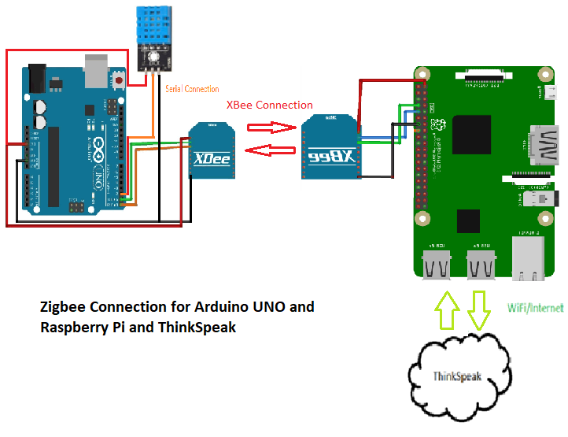

IV. Conclusion
This lab helped us read real-time data and display it on the internet. The temperature sensing system using DHT11 temperature sensor wired to the Arduino Uno, the data from the sensors transmitted via Bluetooth using the HC-06 module to Raspberry Pi and upload the received data to ThinkSpeak to visualize the sensor data graphically online.
References
[1] Experiment 1 Lab Manual
[2] Lecture Note 3 of ECE 442/510

Appendix
- Lab3.py Raspberry Pi Program
import bluetooth # needed for bluetooth communication
import thingspeak # needed for thingspeak

bluetooth_addr = "00:20:12:08:2A:D8" # The address from the HC-06 sensor
bluetooth_port = 1 # Channel 1 for RFCOMM
bluetoothSocket = bluetooth.BluetoothSocket (bluetooth.RFCOMM)
bluetoothSocket.connect((bluetooth_addr,bluetooth_port))

#thingspeak information
channel_id = 1758168 # channel ID from your Thingspeak channel
key = "5CB3I11C59J5LTMY" # obtain from Thingspeak
url = 'https://api.thinkspeak.com/update' # default URL to update Thingspeak
ts = thingspeak.Channel(channel_id, key, url)

while 1:
try:
received_data = bluetoothSocket.recv(1024)
temperature = int.from_bytes(received_data,byteorder='big')
print("Current Temperature: %d" % temperature)
thingspeak_field1 = {"field1": temperature}
ts.update(thingspeak_field1) # update thingspeak

except KeyboardInterrupt:
print("keyboard interrupt detected")
break
bluetoothSocket.close()

- Code on Arduino
#include <SoftwareSerial.h>
#include "dht.h"

SoftwareSerial mySerial(5, 6); // RX, TX
#define DHT_Sensor 7
dht sensor;

void setup() {
// Open serial communications and wait for port to open:
Serial.begin(9600);
mySerial.begin(38400);
}

void loop() { // run over and over
sensor.read11(DHT_Sensor);
float tc=sensor.temperature;
float tf=tc*1.8+32;
Serial.print(tc);
Serial.print("C (");
Serial.print(tf);
Serial.print("F)\t");
mySerial.write(tf);
Serial.println("Bluetooth Transmission Complete");
Serial.flush();
delay(1000);
}

- dht.h
//
// FILE: dht.h
// AUTHOR: Rob Tillaart
// VERSION: 0.1.29
// PURPOSE: DHT Temperature & Humidity Sensor library for Arduino
// URL: http://arduino.cc/playground/Main/DHTLib
//
// HISTORY:
// see dht.cpp file
//

#ifndef dht_h
#define dht_h

#if ARDUINO < 100
#include <WProgram.h>
#include <pins_arduino.h> // fix for broken pre 1.0 version - TODO TEST
#else
#include <Arduino.h>
#endif

#define DHT_LIB_VERSION "0.1.29"

#define DHTLIB_OK 0
#define DHTLIB_ERROR_CHECKSUM -1
#define DHTLIB_ERROR_TIMEOUT -2
#define DHTLIB_ERROR_CONNECT -3
#define DHTLIB_ERROR_ACK_L -4
#define DHTLIB_ERROR_ACK_H -5

#define DHTLIB_DHT11_WAKEUP 18
#define DHTLIB_DHT_WAKEUP 1

#define DHTLIB_DHT11_LEADING_ZEROS 1
#define DHTLIB_DHT_LEADING_ZEROS 6

// max timeout is 100 usec.
// For a 16 Mhz proc 100 usec is 1600 clock cycles
// loops using DHTLIB_TIMEOUT use at least 4 clock cycli
// so, 100 us takes max 400 loops
// so, by dividing F_CPU by 40000 we "fail" as fast as possible
#ifndef F_CPU
#define DHTLIB_TIMEOUT 1000 // ahould be approx. clock/40000
#else
#define DHTLIB_TIMEOUT (F_CPU/40000)
#endif

class dht
{
public:
dht() { _disableIRQ = false; };
// return values:
// DHTLIB_OK
// DHTLIB_ERROR_CHECKSUM
// DHTLIB_ERROR_TIMEOUT
// DHTLIB_ERROR_CONNECT
// DHTLIB_ERROR_ACK_L
// DHTLIB_ERROR_ACK_H
int8_t read11(uint8_t pin);
int8_t read(uint8_t pin);
int8_t read12(uint8_t pin);

inline int8_t read21(uint8_t pin) { return read(pin); };
inline int8_t read22(uint8_t pin) { return read(pin); };
inline int8_t read33(uint8_t pin) { return read(pin); };
inline int8_t read44(uint8_t pin) { return read(pin); };
inline int8_t read2301(uint8_t pin) { return read(pin); };
inline int8_t read2302(uint8_t pin) { return read(pin); };
inline int8_t read2303(uint8_t pin) { return read(pin); };
inline int8_t read2320(uint8_t pin) { return read(pin); };
inline int8_t read2322(uint8_t pin) { return read(pin); };

bool getDisableIRQ() { return _disableIRQ; };
void setDisableIRQ(bool b ) { _disableIRQ = b; };

float humidity;
float temperature;

private:
uint8_t bits[5]; // buffer to receive data
int8_t _readSensor(uint8_t pin, uint8_t wakeupDelay, uint8_t leadingZeroBits);
bool _disableIRQ;
};
#endif
//
// END OF FILE
//

- dht.cpp
//
// FILE: dht.cpp
// AUTHOR: Rob Tillaart
// VERSION: 0.1.29
// PURPOSE: DHT Temperature & Humidity Sensor library for Arduino
// URL: http://arduino.cc/playground/Main/DHTLib
//
// HISTORY:
// 0.1.29 2018-09-02 fix negative temperature DHT12 - issue #111
// 0.1.28 2018-04-03 refactor
// 0.1.27 2018-03-26 added _disableIRQ flag
// 0.1.26 2017-12-12 explicit support for AM23XX series and DHT12
// 0.1.25 2017-09-20 FIX https://github.com/RobTillaart/Arduino/issues/80
// 0.1.24 2017-07-27 FIX https://github.com/RobTillaart/Arduino/issues/33 double -> float
// 0.1.23 2017-07-24 FIX https://github.com/RobTillaart/Arduino/issues/31
// 0.1.22 undo delayMicroseconds() for wakeups larger than 8
// 0.1.21 replace delay with delayMicroseconds() + small fix
// 0.1.20 Reduce footprint by using uint8_t as error codes. (thanks to chaveiro)
// 0.1.19 masking error for DHT11 - FIXED (thanks Richard for noticing)
// 0.1.18 version 1.16/17 broke the DHT11 - FIXED
// 0.1.17 replaced micros() with adaptive loopcount
// removed DHTLIB_INVALID_VALUE
// added DHTLIB_ERROR_CONNECT
// added DHTLIB_ERROR_ACK_L DHTLIB_ERROR_ACK_H
// 0.1.16 masking unused bits (less errors); refactored bits[]
// 0.1.15 reduced # micros call 2->1 in inner loop.
// 0.1.14 replace digital read with faster (~3x) code => more robust low MHz machines.
//
// 0.1.13 fix negative temperature
// 0.1.12 support DHT33 and DHT44 initial version
// 0.1.11 renamed DHTLIB_TIMEOUT
// 0.1.10 optimized faster WAKEUP + TIMEOUT
// 0.1.09 optimize size: timeout check + use of mask
// 0.1.08 added formula for timeout based upon clock speed
// 0.1.07 added support for DHT21
// 0.1.06 minimize footprint (2012-12-27)
// 0.1.05 fixed negative temperature bug (thanks to Roseman)
// 0.1.04 improved readability of code using DHTLIB_OK in code
// 0.1.03 added error values for temperature and humidity when read failed
// 0.1.02 added error codes
// 0.1.01 added support for Arduino 1.0, fixed typos (31/12/2011)
// 0.1.00 by Rob Tillaart (01/04/2011)
//
// inspired by DHT11 library
//
// Released to the public domain
//

#include "dht.h"

/////////////////////////////////////////////////////
//
// PUBLIC
//

int8_t dht::read11(uint8_t pin)
{
// READ VALUES
if (_disableIRQ) noInterrupts();
int8_t result = _readSensor(pin, DHTLIB_DHT11_WAKEUP, DHTLIB_DHT11_LEADING_ZEROS);
if (_disableIRQ) interrupts();

// these bits are always zero, masking them reduces errors.
bits[0] &= 0x7F;
bits[2] &= 0x7F;

// CONVERT AND STORE
humidity = bits[0]; // bits[1] == 0;
temperature = bits[2]; // bits[3] == 0;

// TEST CHECKSUM
uint8_t sum = bits[0] + bits[1] + bits[2] + bits[3];
if (bits[4] != sum)
{
return DHTLIB_ERROR_CHECKSUM;
}
return result;
}

int8_t dht::read12(uint8_t pin)
{
// READ VALUES
if (_disableIRQ) noInterrupts();
int8_t result = _readSensor(pin, DHTLIB_DHT11_WAKEUP, DHTLIB_DHT11_LEADING_ZEROS);
if (_disableIRQ) interrupts();

// CONVERT AND STORE
humidity = bits[0] + bits[1] * 0.1;
temperature = bits[2] + (bits[3] & 0x7F) * 0.1;
if (bits[3] & 0x80) // negative temperature
{
temperature = -temperature;
}

// TEST CHECKSUM
uint8_t sum = bits[0] + bits[1] + bits[2] + bits[3];
if (bits[4] != sum)
{
return DHTLIB_ERROR_CHECKSUM;
}
return result;
}

int8_t dht::read(uint8_t pin)
{
// READ VALUES
if (_disableIRQ) noInterrupts();
int8_t result = _readSensor(pin, DHTLIB_DHT_WAKEUP, DHTLIB_DHT_LEADING_ZEROS);
if (_disableIRQ) interrupts();

// these bits are always zero, masking them reduces errors.
bits[0] &= 0x03;
bits[2] &= 0x83;

// CONVERT AND STORE
humidity = (bits[0]*256 + bits[1]) * 0.1;
temperature = ((bits[2] & 0x7F)*256 + bits[3]) * 0.1;
if (bits[2] & 0x80) // negative temperature
{
temperature = -temperature;
}

// TEST CHECKSUM
uint8_t sum = bits[0] + bits[1] + bits[2] + bits[3];
if (bits[4] != sum)
{
return DHTLIB_ERROR_CHECKSUM;
}
return result;
}

/////////////////////////////////////////////////////
//
// PRIVATE
//

int8_t dht::_readSensor(uint8_t pin, uint8_t wakeupDelay, uint8_t leadingZeroBits)
{
// INIT BUFFERVAR TO RECEIVE DATA
uint8_t mask = 128;
uint8_t idx = 0;

uint8_t data = 0;
uint8_t state = LOW;
uint8_t pstate = LOW;
uint16_t zeroLoop = DHTLIB_TIMEOUT;
uint16_t delta = 0;

leadingZeroBits = 40 - leadingZeroBits; // reverse counting...

// replace digitalRead() with Direct Port Reads.
// reduces footprint ~100 bytes => portability issue?
// direct port read is about 3x faster
uint8_t bit = digitalPinToBitMask(pin);
uint8_t port = digitalPinToPort(pin);
volatile uint8_t *PIR = portInputRegister(port);

// REQUEST SAMPLE
pinMode(pin, OUTPUT);
digitalWrite(pin, LOW); // T-be
if (wakeupDelay > 8) delay(wakeupDelay);
else delayMicroseconds(wakeupDelay * 1000UL);
// digitalWrite(pin, HIGH); // T-go
pinMode(pin, INPUT);

uint16_t loopCount = DHTLIB_TIMEOUT * 2; // 200uSec max
// while(digitalRead(pin) == HIGH)
while ((*PIR & bit) != LOW )
{
if (--loopCount == 0)
{
return DHTLIB_ERROR_CONNECT;
}
}

// GET ACKNOWLEDGE or TIMEOUT
loopCount = DHTLIB_TIMEOUT;
// while(digitalRead(pin) == LOW)
while ((*PIR & bit) == LOW ) // T-rel
{
if (--loopCount == 0)
{
return DHTLIB_ERROR_ACK_L;
}
}

loopCount = DHTLIB_TIMEOUT;
// while(digitalRead(pin) == HIGH)
while ((*PIR & bit) != LOW ) // T-reh
{
if (--loopCount == 0)
{
return DHTLIB_ERROR_ACK_H;
}
}

loopCount = DHTLIB_TIMEOUT;

// READ THE OUTPUT - 40 BITS => 5 BYTES
for (uint8_t i = 40; i != 0; )
{
// WAIT FOR FALLING EDGE
state = (*PIR & bit);
if (state == LOW && pstate != LOW)
{
if (i > leadingZeroBits) // DHT22 first 6 bits are all zero !! DHT11 only 1
{
zeroLoop = min(zeroLoop, loopCount);
delta = (DHTLIB_TIMEOUT - zeroLoop)/4;
}
else if ( loopCount <= (zeroLoop - delta) ) // long -> one
{
data |= mask;
}
mask >>= 1;
if (mask == 0) // next byte
{
mask = 128;
bits[idx] = data;
idx++;
data = 0;
}
// next bit
--i;

// reset timeout flag
loopCount = DHTLIB_TIMEOUT;
}
pstate = state;
// Check timeout
if (--loopCount == 0)
{
return DHTLIB_ERROR_TIMEOUT;
}

}
// pinMode(pin, OUTPUT);
// digitalWrite(pin, HIGH);
return DHTLIB_OK;
}
//
// END OF FILE
//

